British Fencing
Sporting Excellence Award

Sporting Excellence Award Information
British Fencing is committed to providing fencers with opportunities to improve performance and develop as individuals in a cost effective way. The British Fencing AASE programme will become the Sporting Excellence Award due to the changing nature of the government’s Apprenticeship standard. We have worked with South Gloucestershire and Stroud College (SGS) to offer you the chance of being part of this programme and achieving the Award

All 16-18 year olds who have completed their GCSE year and are ranked in the top 40 (for their age on any national ranking list) are eligible to apply for this British Fencing programme.

Universities and Colleges Admissions Service (UCAS) Tariff 2017
Fencers who successfully complete the Sporting Excellence Award will get the following qualifications (these may be with different awarding bodies but will still be on the UCAS tariff):-
Pearson BTEC Certificate in Understanding Sports Performance
Pearson Edexcel Certificate in Achieving Excellence in Sports Performance

On the UCAS tariff calculator at https://www.ucas.com/ucas/undergraduate/getting-started/entry-requirements/tariff/calculator these certificates are worth 32 points towards University application.

What is the Sporting Excellence Award?
It is a Level 3 qualification based around NVQs (National Vocational Qualification) in Achieving Excellence in Sports Performance and Understanding Sports Performance. It is designed for fencers who have the realistic potential to achieve excellence and are seeking to perform at the highest level. The programme will cover all areas of your training, will help you to develop as an athlete and fencer, and gain a UCAS-recognised qualification.

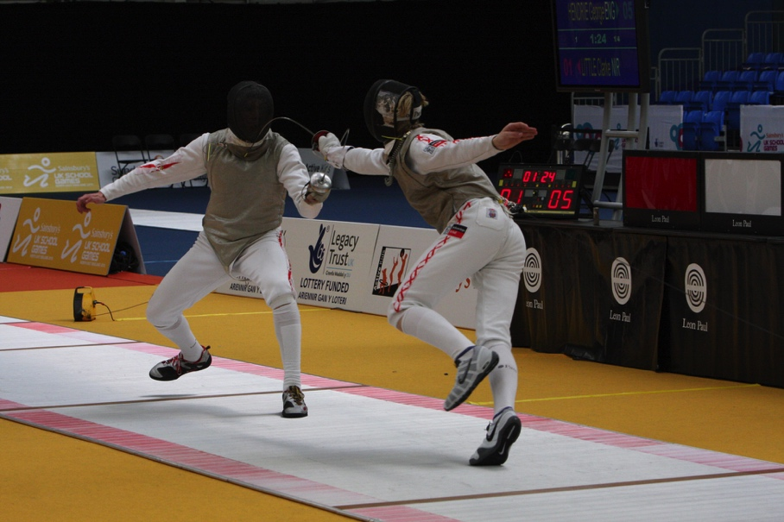
The award is notionally a 2-year programme for fencers aged16-18 on the 1st September 2017. They can be studying other academic qualifications at a school or college of further education. Fencers must have completed their GSCE level qualifications and cannot combine this with University education or other Level 4 qualification. So normally fencers will start at the beginning of year 12.

The British Fencing programme offers fencers the ability to stay at their current school or college. The majority of the programme will be delivered through 20-25 contact days at weekends or in school holidays.
The programme will begin in October 2017 and run as an 18-month programme, finishing in February 2019.

- Available to fencers resident in England only, we cannot accept applicants who do not have an address in England
- Fencers must be aged 16, 17, or 18 on the 1st September in the academic year (for September 2017 intake born between 2/9/1998 & 1/9/2001)
- Fencers should have completed their GCSE year before starting
- Applicants must be in the top 40 in Britain at their age group
- Fencers will need to commit to attending training days (approx. 20-25 days a year), to maintaining a portfolio of their learning and training activity, and to complete the course.

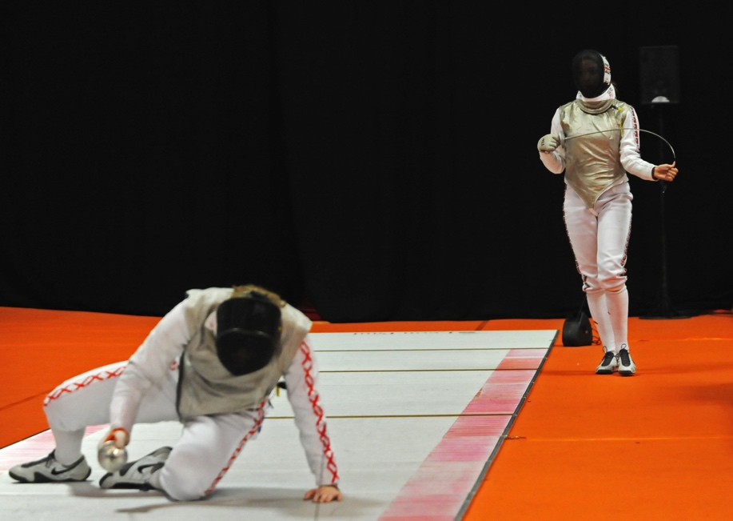
The Sporting Excellence Award is a direct replacement for the Advanced Apprenticeship in Sporting Excellence (AASE) in all non-professional sports such as fencing. There are currently 50 British fencers enrolled in this programme and see details of this programme below.
AASE Programme Information
The AASE programme reflects the broad range of skills, knowledge and performance required by elite level sports people. It is designed to measure the athlete’s ability to plan, apply and evaluate their development in the technical, tactical, physical and psychological aspects of their sport. It also addresses wider issues such as lifestyle, career development, communication, and health and safety.
The AASE programme currently runs in the following sports: Athletics, Badminton, Basketball, Boxing, Cricket, Fencing, Football, Golf, Handball, Judo, Lacrosse, Modern Pentathlon, Motor Sports, Netball, Rugby Union, Swimming, Table Tennis, and Tennis.
There are currently over 2500 athletes enrolled in the programme.
AASE is designed to directly measure the athlete’s ability to apply themselves to “professional” development in their sports, covering:
- Technical Skills
- Tactical Awareness
- Physical Capabilities
- Mental Skills
Importantly it also directly addresses wider issues, such as:
- Lifestyle Organisation
- Career Planning
- Communication and Working With Others,
- Health & Safety
- Nutrition
These nine areas of focus directly contribute towards achievement of the certificates in the AASE Framework

What do I need to do?
If you wish to be involved with this innovative and exciting programme, or if you want more information, please complete the expression of interest form on the British Fencing web site at http://www.britishfencing.com/development/aaseprogramme/. Completing the form does not commit you to start the programme at this stage.

If you feel that the British Fencing Sporting Excellence Award programme is something you may be interested in do not hesitate to contact Neil Brown neil.brown@britishfencing.com

