

**Robert Kiss SUMMER Training Camp**

**BUDAPEST 7TH-11TH AUGUST 2017**

For all 3 weapons

* £230 for 5 days intensive training at the newly refurbished

VASAS Sport Centrum. The Cost only includes the training.

* The Camp is suitable for all ages and abilities.
* We usually organise social programmes between and after sessions
  + Chilling out in waterparks, climbing, eating out, shopping and sightseeing.
* We are happy to advise you where to book your Hotel or help with any other information.

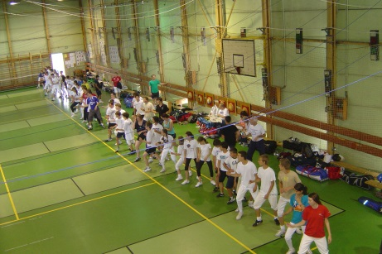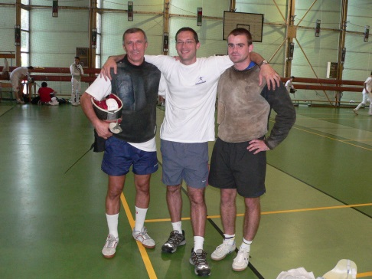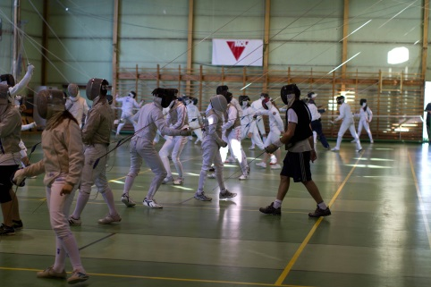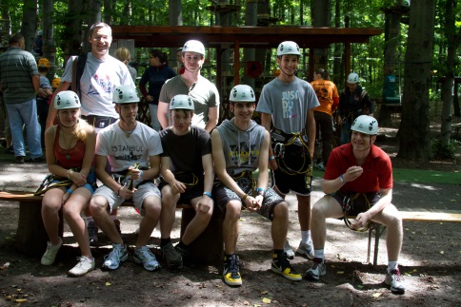

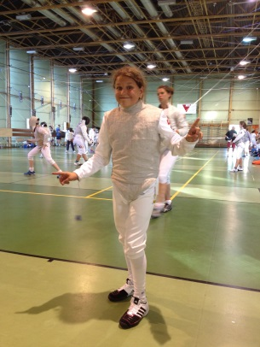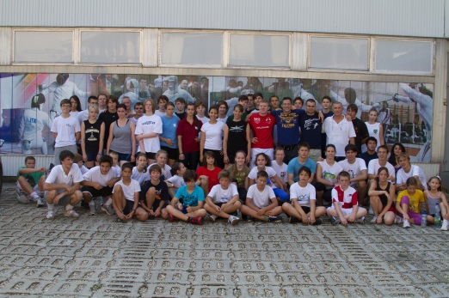

**You could find out more about the camp on our website:** [**www.sallekiss.org.uk**](http://www.sallekiss.org.uk)

**To make your reservation, please contact us :**[**robertandnatalia@gmail.com**](mailto:robertandnatalia@gmail.com) **or call 07887968117**