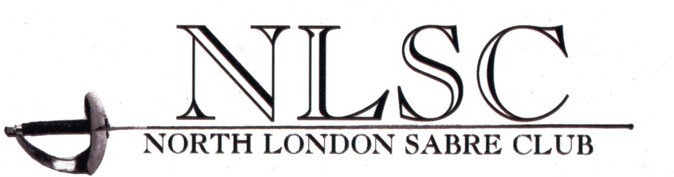

The Hertfordshire Open Sabre 2017

North London Sabre Club presents the eight Hertfordshire Open Sabre Competition. Maximum entry size will be limited to 64 fencers in both the Men’s and Women’s events. Top 30 ranked fencers will be guaranteed a place provided they enter by the closing date. All other entries will be accepted in order of receipt.

For further information email info@nlsc.co.uk.

DATE: SUNDAY 21 May 2017
VENUE: HERTS SPORTS VILLAGE, DE HAVILLAND CAMPUS, HATFIELD BUSINESS PARK, HATFIELD
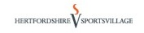
SEE WEBSITE AT WWW.HERTSSPORTSVILLAGE.CO.UK FOR MAPS AND VENUE DETAILS. PLENTY OF PARKING AVAILABLE AND CAFETERIA TO PURCHASE FOOD AND DRINK.

REPORT TIMES:
MEN’S SABRE ....10.30am WOMEN’S SABRE....11.30am

ENTRY FEES
SENIOR EVENTS £25.00. LATE ENTRIES: £35.00. ENTRIES ON THE DAY: £40.00 IF SPACE PERMITS.

CLOSING DATE – MONDAY 15 MAY 2017
ENTRIES TO:
Online entries only via Leon Paul’s online entry system http://leonpaulfencingcentre.com/competitions

FORMAT:
One round of poules followed by direct elimination. All fencers will be promoted to the direct elimination bouts. The organisers reserve the right to alter the format in light of the entry sizes and conditions of the day.

PRIZES:
Gold, Silver, Bronze, best cadet and best veteran

MEMBERSHIPS:
All fencers must have a valid BFA membership to compete. These will be checked against the BFA database. Any fencer entering without a valid membership will be unable to fence and the entry fee will not be refunded. An FIE or other national fencing license will not be accepted.

ENTRY ON THE DAY:
Entry on the day will be accepted provided the entry limit for the event has not been reached. Any fencer wishing to enter on the day must arrive and submit full payment (including late fee), 30 minutes before the closing of check-in. Proof of BFA membership will be required.

DISCLAIMER:
By entering the tournament fencers acknowledge that they do so at their own risk and that the organisers accept no liability for loss, damage or personal injury whatsoever during the event.

